**Case Studies on Interaction Management, Problem Solving, Decision Making, Developing Team & Coaching Performance on Marugame & IPMI Institute**

Irma M Nawangwulan1, Samuel PD Anantadjaya2, Sasotya Pratama3,Abdul Haris Lahuddin4, Daniella CE Samuel5,DC Ethan Samuel6, Timotius Agus Rachmat7, Mohammad Wahiddudin8

1,2,3IPMI Institute, Kalibata, Jakarta, 4PII (Persatuan Insinyur Indonesia), Badan Kejuruan Teknik Industri, Jakarta, 5Universitas Bunda Mulia, Alam Sutera, Tangerang, 6Padepokan Kalisonga, Brebes, 6Department of Hotel Business, Universitas Podomoro, 8SagalaVibe, Bandung

Author Email: [irma.nawangwulan@ipmi.ac.id](mailto:irma.nawangwulan@ipmi.ac.id), [ethan.eryn@gmail.com](mailto:ethan.eryn@gmail.com), [sasotya.pratama@ipmi.ac.id](mailto:sasotya.pratama@ipmi.ac.id), [abharis99@gmail.com](mailto:abharis99@gmail.com), [erynsamuel123@gmail.com](mailto:erynsamuel123@gmail.com), [ethan.1812.samuel@gmail.com](mailto:ethan.1812.samuel@gmail.com), [timotiusrachmat14@gmail.com](mailto:timotiusrachmat14@gmail.com), [mohammadw7878@gmail.com](mailto:mohammadw7878@gmail.com),

**JEL: M10, M30, M50, M14**

**ABSTRACT**

*This case study explores the strategic and operational practices of Marugame Udon, a leading Japanese fast-casual restaurant chain, and IPMI Institute, a premier Indonesian institution in business education. By analyzing both organizations through the lenses of interaction management, problem-solving, decision-making, team development, and coaching performance, the study uncovers practical insights into effective organizational behavior across different industries. At Marugame, the emphasis on lean operations and team coordination plays a critical role in ensuring customer satisfaction and operational efficiency. Through real-time interaction management and standardized communication protocols, Marugame fosters a service-oriented culture where frontline staff are empowered to solve problems and make quick decisions. Leadership coaching is implemented at the store level to improve service performance and employee retention. In contrast, IPMI Institute emphasizes strategic decision-making and collaborative learning in academic and administrative settings. Faculty and management engage in structured problem-solving through academic councils, while team development is cultivated through cross-functional projects and coaching initiatives, particularly in student-led consulting and entrepreneurship programs. The coaching culture at IPMI Institute fosters professional growth, critical thinking, and emotional intelligence among both staff and students. The findings highlight that both organizations, while operating in different sectors, leverage similar core principles of organizational development. Interaction management and coaching serve as the backbone for efficient teamwork and agile decision-making. Furthermore, this comparative case analysis underscores the value of context-specific adaptations of these practices, reinforcing the need for tailored leadership approaches in hospitality and education sectors.*

**Keywords**: Managerial Capacity; Technical Capacity; Core Competencies; Operational Task; Strategic Task; Academic Skill; Development Life Skill

**Introduction**

Referring to the official Marugame website, it is stated that Marugame Udon first opened in Indonesia on February 14, 2013 at Mall Taman Anggrek (Marugame Udon, 2025). All recipes used are original recipes from Marugame Japan, which are cooked using quality and natural ingredients and processed in each outlet with special techniques from Japan and controlled with strict quality assurance standards in each outlet. Marugame Udon already has branches in various major cities in Indonesia and currently has more than 1100 branches around the world, such as in Los Angeles, Hawaii, Moscow, Sydney, Seoul, Hong Kong and other major cities in the world (Marugame Udon, 2025; PT. Sriboga Raturaya, 2025).

In Indonesia, Marugame Udon has received MUI halal certification on October 7, 2015 and is committed to continuing to serve the best Udon and Tempura to its loyal customers. This is expected to be a reference for customers to continue to be part of Marugame Udon's daily operations.

In business management, Marugame Udon has developed 18 areas throughout Indonesia, as part of a strategy to fulfill customer needs. These 18 business areas oversee various outlets in major cities in Indonesia, spread from Medan to Manado, Denpasar and Lombok. Each area is managed by an Area Manager, who has direct contact with the Outlet Manager and various other supporting work units at the Jakarta head office, including the LSM (local sales manager) who is responsible for sales in each area. In its development, these area managers apparently need various competencies, both technical operational and managerial, in order to carry out the tasks, responsibilities and targets assigned. Overall, 10 types of competencies are identified that are needed by these area managers, consisting of 5 technical operational competencies and 5 managerial leadership competencies, which urgently need to be built and developed in the near future. In detail, the 10 types of competencies will be described in the following slides, which form a specific competency model.

**Identification and Problem Formulation**

Referring to the needs of the Marugame organization and the Area Manager profile, the identification of the company's needs for improving the competency of area managers is related to:

1. Communication, or it is called the Interaction Management is the ability to convey information and ideas clearly through various media to individuals or groups in a way that involves and helps the audience to understand and remember the interaction being carried out.
2. Problem Solving and Decision Making are ability to identify and understand issues, problems and opportunities, compare data from various sources to draw conclusions, use effective approaches to select a course of action or develop appropriate solutions and take actions that are consistent with the facts, limitations and consequences
3. Team Development, or it is called the Developing High Performing Team is ability to use appropriate interpersonal methods and styles to develop, motivate and guide a team towards success and achievement of business goals
4. Planning and Organizing, or it is referred to as Strategic Cascading and Goal Setting are ability to develop a course of action for oneself, the team and others to ensure that all tasks can be completed effectively and efficiently
5. Coaching for Developing Others, or Coaching Performance is ability to provide feedback, coaching and development guidance to help teams and others master their current and future work and responsibilities and plan and support the development of team and others' skills and abilities

**Solutions and Output**

Referring to the needs of the Marugame organization and the profile of the Area Manager who is the target group for organizational development, the proposed program solution has the following objectives:

1. Managerial and Technical Competencies Development are ​​developing understanding, mastery and application of various competencies that are very much needed in carrying out daily tasks, responsibilities and authorities related to the position as Area Manager, both in terms of operational technical competencies which are technical skills and managerial leadership which are behavioral
2. Academic Ability Development is to further ​​developing formally recognized academic abilities through level education, by following a structured and systematic academic learning process in accordance with a specific curriculum and learning syllabus, which is organized by a higher education institution that has proven credibility in the appropriate field
3. Life Skills Exposure is developing daily abilities and skills that support all work processes carried out while holding a position as Area Manager, both formally as a head of a work unit, as a professional in a particular business field or as an individual

**Implementation Method**

The activity implementation method is as follows;

1. Program Planning and Development is the initial stage of the program, where Marugame as the program owner will work together with IPMI Institute, as the program implementer, to develop various activities related to this proposed program. Thus, this stage is intended to build, develop and prepare the program implementation plan, both related to the participant preparation process (considering the length of the program which requires commitment and coordination between Marugame management and participants) and related to material content, supporting instruments, methodology and learning evaluation. The three main activities that will be carried out in this stage are
2. Program Planning in this exercise, Marugame management and IPMI will work together to prepare a program implementation plan, including the program curriculum, learning syllabus per topic and program implementation (place, time, participants, teachers and others). All information generated in this activity must be compiled in the form of an information pack that will be socialized to the participants. Thus, this activity will be dominated by Marugame management, especially in the preparation and socialization of information
3. Development of Learning Materials and Instruments - this activity is the core of all these stages, where IPMI will develop learning materials and instruments related to the program that has been developed. The program curriculum and learning syllabus produced from previous activities will be expanded into materials, instruments and other supporting activities for each topic that will be delivered during the program, including monitoring or assessment instruments and learning evaluation (pre and post-test). This activity will also include the trial and finalization of the instrument, so that all materials and instruments will be ready for use during the program
4. Development and Preparation of Learning Management System (LMS) a whole requires an online supporting learning system, which allows all data and information related to the program to be documented and monitored in real-time. This activity will prepare the LMS using ed-link as the main LMS, as is also used by IPMI students in carrying out the daily learning process. Overall, this stage must be mutually agreed upon by Marugame Management and IPMI, so as to enable the achievement of optimal final results in preparing for the next program implementation process.

|  |  |
| --- | --- |
|  |  |

Figure : Presentation of Individual Strategy of Marugame

1. Preparation for Implementation is a stage to prepare the program as a whole, including participants, teachers, coaches and other supporters, in order to be able to provide optimal impact on the program. Thus, the largest part of this stage is preparing the human resources involved, so that the 2 main activities that will be carried out during this stage are:
2. Program Socialization is actually where all information about the program that has been compiled in the form of an information pack that has been produced in stage 1, will be socialized to the participants. This socialization process will begin with a program kick-off which should be carried out by Marugame's top manager, attended by all participants and various other related parties. This kick-off process will be used by Marugame management to explain in detail and completely the reasons, objectives, results to be achieved and the processes that will be carried out during the program. It is hoped that this explanation will provide a deep understanding for the participants so that they can prepare intensively. On the other hand, this explanation is expected to provide an overview to all HR related to the program, regarding the importance of the program in the Marugame HR development process in supporting the achievement of overall business results. In this activity, participants will also be introduced to the details of the program in detail, including the process, assignments, final results, guidance and subsequent follow-up programs. This is intended as part of the program introduction before carrying out the program as a whole, so that participants can understand and explore the process that will be carried out next.
3. Pre-work Work and Delivery will begin with individual assignments as initial tasks before the program (pre-work). Basically, this pre-work is intended to provide participants with an overview of the material that will be studied during the program, as well as a database for the program regarding the level of knowledge and skills currently possessed by participants. This pre-work consists of 2 parts, namely:

* Compiling Individual Profiles – as an effort to build the profile and self-image of the participants, according to the image they have
* Completing Pre-tests – testing the level of understanding of participants towards the learning material in general Overall, all of this pre-work must have been sent via LMS before the program begins.

1. Implementation is the core part of the entire process that has been prepared, where this stage will fully focus on the implementation of the program, including the implementation of tasks, both individually and in groups Overall, this stage will be carried out in 12 weeks and will consist of 4 interrelated phases, which can be seen in detail in the following slides, namely
2. Phase 1 Basic Knowledge – which is carried out during the first week, which will fully focus on efforts to build and develop a deep understanding of the various competencies expected of the participants. The 10 competencies that have been described previously (5 technical competencies and 5 managerial leadership competencies) will be built, developed and deepened during this phase. Given that this phase is an in-class learning phase, the learning method will focus on lectures, discussions and skills training. The case method will also be introduced in this phase, where participants will have in-depth discussions during class on cases that are similar to everyday cases. In this phase, participants will study 10 competencies simultaneously, plus various assignments, both group and individual, as an effort to deepen the material given and prepare themselves for the material on the following day
3. Phase 2 Group Assignment - which is carried out for the next 5 weeks, where participants are divided into groups (maximum 4 people) and given group assignments. Each group in this assignment will be fully guided by 1 coach who will provide feedback, observation and documentation of the entire process carried out
4. Phase 3 Individual Empowerment - which is carried out during the 7th week and focuses on efforts to empower individuals in optimizing various competencies that have been owned, developed and carried out daily. This phase is the IPMI certification phase, so participants are expected to be able to optimally follow this phase in full, including individual and group assignments, considering that this phase is very dense with assignments
5. Phase 4 Final Project - which is carried out during weeks 8 to 12, where each individual will be guided by 1 coach in the same topic group. The final results of this phase, in the form of an activity proposal, will be presented in week 12, and will also close the entire series of this program

​​**Schedule of Activities**

This program is held, as per the following timeline:

1. The first month is about the introduction and pretest. This is to conduct the introduction to basic concept which is to cover both technical and leadership skills, including several assignments (group and individual) related to the topics studied (5 days of training). Then, the next one is about the introduction to group assignments where the group consists of 5 participants guided by 1 coach (will be carried out in 3 weeks of assignment)
2. The second month is about group assignment presentation (1 day), presentation competency development for obtaining the IPMI certifications (2 days of training), strategic leadership development (1 day of training), introduction to individual assignments, which are intended as the preparation of the 2025 Strategic Plan for Task Areas where every 5 participants will be guided by 1 coach (1 day of training) with the next one to individual assignments (3 weeks of assignment)
3. The third month is about the finalization and preparation of individual assignment exhibition (1 day of training), individual assignment exhibition and presentation (1 day), post-test, program evaluation, program closing and submission of program certificates

|  |  |
| --- | --- |
|  |  |

Figure : Individual Strategy on What Matters to Marugame

**Method**

This activity was attended by 30 participants from various divisions, including the Operations Division and the Restaurant Support Center (RSC) Division. This program uses an outcome-based education (OBE) learning method with a combination of class sessions, group projects, and Coaching sessions.

One of the key components is a field trip to the Marugame outlet in Kota Bintang, Bekasi, which allows participants to apply the theories they have learned in a real work environment. The evaluation results showed a significant increase in participant competency, especially in the aspects of communication, decision-making, and team management. This program also opens up opportunities for participants to continue their academic level through the Recognition of Prior Learning (RPL) scheme. With this comprehensive approach, the program has succeeded in providing a positive impact in improving participants' managerial readiness and effectiveness in a dynamic business environment.

|  |
| --- |
|  |

Figure : Individual Personnel to Discuss What Matters on Marugame

**Conclusion**

Referring to the learning process that has been carried out during the program and the final results achieved through this program, there are a series of programs that IPMI can propose as a form of follow-up to this program. Overall, these three proposals are not entirely related to competency development, but rather focus on efforts to develop the various potentials possessed by participants and SMI as an organization. The follow-up onto the results were;

* Academic Development to mirror onto the efforts to improve the academic abilities of some participants, who have not achieved and have a certain academic level as a general prerequisite. During the implementation of this program, it is very much felt that there is a need to improve academic competence, to be able to encourage the improvement and expansion of insight, mindset and analytical skills, which can develop a level of self-confidence in the decision-making process, initiative and creativity. This is important to be accommodated considering that some participants tend to hold back from contributing maximally given the limitations of insight, thought processes and analytical skills they have
* Leadership Capability Development to cover the limitations of participants in creativity, initiative, decision-making and division of tasks were very much felt. Basically, these four competencies were part of the leadership role that participants should have at this time. It was felt that there is a need to develop a leadership capability development program, considering the lack of individual ability of the participants to demonstrate attitudes and abilities in leading groups, both formally and informally, as long as it was aim at achieving optimal performance together. What was currently felt was the unpreparedness of the participants to carry out the role as leaders due to the lack of provisions provided
* Peer Collaboration developments that occurred during the implementation of the program also showed the growing need for sharing, collaborating and working together between individuals and work units. It was felt that there was a need to be able to encourage and build

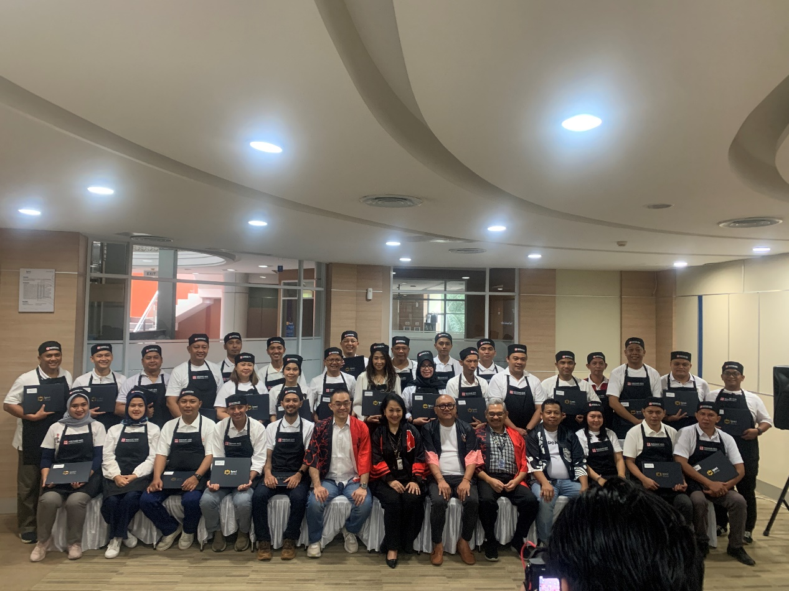

Figure : The Team Marugame with Board of Management and Lecturers of IPMI Institute

**References**

Marugame Udon. (2025). *Marugame Udon*. https://www.marugameudon.co.id

PT. Sriboga Raturaya. (2025). *PT. Sriboga Raturaya*. https://www.sriboga.com/