Journal of Humanities and Social Studies
Vol. 7, no. 3, 2023, p. 1050-1055
e-ISSN # 2598-120X/p-ISSN # 2598-117X

Analysis Of The Health Level Of Cooperative Financial Statements With The Camels Method
By: Samuel PD Anantadjaya, Renika Hasibuan, Irwan Moridu, Sumartono Sumartono, Sufyati HS

https://journal.unpak.ac.id/index.php/jhss/issue/view/633
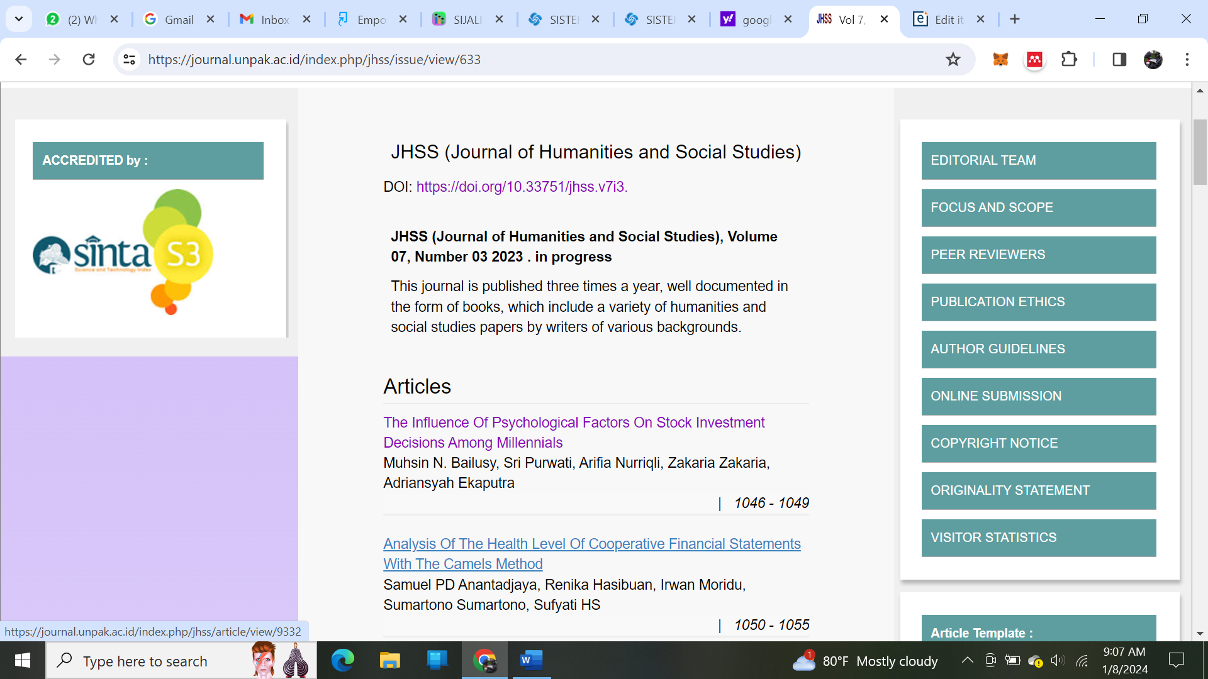

https://journal.unpak.ac.id/index.php/jhss/article/view/9332/0
