Supply Chain Performance of SMEs: How is the Role of Trust, Commitment, and Information Technology?

Samuel P.D. Anantadjaya*, Irma M. Nawangwulan
ethan.eryn@gmail.com, mnwulan@gmail.com

IULI - International University Liaison Indonesia

Krisdiana
krisdiana33@gmail.com

Universitas Swadaya Gunung Djati

Timotius A Rachmat
timotiusrachmat14@gmail.com

Universitas Agung Podomoro

Aditya N. Putra
aditya.nova01@gmail.com

IULI - International University Liaison Indonesia

Abstract
This study investigated the effects of dedication, information technology, trust, and SMEs' supply chain performance. This study relies on a questionnaire and documentation. Variables and indicators are measured on a 1–5 Likert Scale. Data is acquired through observing the management or business owner. Field data was collected after instrument trial. The Cronbach's alpha test showed reliability, whereas the Pearson correlation coefficient showed validity. After validating the instrument, field data is collected. The respondents completed 280 of 340 surveys. Data was analyzed using PLS-PM and descriptive statistics (Partial Least Square-Path Modeling). This method analyzes the structural (inner) and measurement (outer) models. The inner model shows how to estimate latent variables, whereas the outside model shows how the manifest variable represents the hidden variable it measures. Trust drives commitment, which influences supply chain performance for SMEs, according to the report. Supply chain performance is unaffected by IT.

Keywords: Supply chain performance, SMEs, trust, commitment, information technology
- Introduction

SMEs in Indonesia play a significant role as the foundation of the country’s economy in this post-pandemic age. To support the roles, responsibilities, and powers of Bank Indonesia in the areas of monetary policy, macroprudential regulation, and payment systems [1]. [2] claim that in order to achieve productive, inventive, and adaptable SMEs, the SME development program should be based on 3 (three) policy pillars, namely corporatization, capacity building, and expanding access to financing. In an endeavor to create SMEs in Indonesia, the government, associations, and communities [3], [4] In a period of intense global competition, a company’s suppliers, internal operations, and customers must have strong ties. One of the key tactics for raising supply chain efficiency is supply chain integration. The value that all participants in a supply chain system share can be increased through effective integration. Interconnected business processes can also enhance the performance of the supply chain through reduced operational costs, quick turnaround times, low inventory levels, and greater enterprise dependability of SMEs. Supply chain management, as defined by [1], [2], is the integration of business operations, beginning with the receipt of raw materials and continuing with the management of each chain of production activities until the product is ready for use by customers. Major producers, suppliers, manufacturers, retailers, and consumers are all involved in the supply chain process. The movement of information, goods, and money are three consistent flows inside the supply chain, despite its dynamic character. Any supply chain’s primary goal, according to [5], is to satisfy consumer demand while making a profit.
Trust between organizations is one of the most crucial components that each company in a supply chain network should have. [6] assert that trust is a conviction that will lead to favorable outcomes for the company. Trust is defined as a positive belief or expectation acquired via interactions with partners in a supply chain system, according to [5], [6]. According [5], the high value of confidence and steadfast commitment between partners in the supply chain also contribute to the company’s performance (operation performance) in the chain. The partnership process in a supply chain system is described as the interaction of commitment, trust, and collaboration between organizations. Performance is enhanced when suppliers and customers collaborate well. Trust is the foundation of healthy partner relationships. [6], [7] stated that boosting business performance based on positive interactions is how success through cooperation is achieved. The proper implementation of supply chain management (SCM) can increase a company’s competitive edge for its products as well as the supply chain system it has created. The secret to efficient supply chain management is involving suppliers in a company’s plan to adapt to a constantly shifting market. Companies must be able to satisfy customers, develop products on schedule, incur minimal expenses for inventory and product delivery, and handle the market sensibly and flexibly in order to successfully adopt supply SCM.
In the context of the supply chain, the partnership connection has a long-term focus that emerged from a relational approach. [8], [9] both stressed the need of commitment from the partners in long-term relationships. The drive to keep the relationship going and grow it comes from commitment. A key factor in assessing the success of the partnership should be commitment. The quality of the channel relationship between suppliers and distributors increases with the level of commitment created from satisfaction and trust. According to [8], the stronger the commitment that both suppliers and distributors can demonstrate, the more effectively they can work together. Allen and Meyer distinguish between three different kinds of commitment: emotive, continuous, and normative.
According to [2], [4], information is one of the most crucial elements in supply chain management, along with trust and dedication. Management may make business decisions with the use of information technology promptly and accurately. Electronic data exchange (EDI), the internet, and other developments in information and communication technology have become crucial tools for navigating the intricate relationships between suppliers and customers. Companies are compelled to employ online communication solutions due to the complexity of supply chain management. Managers need to be aware of the information gathering and analysis processes given the significance of information in supporting supply chain performance.
Information technology (IT) is defined by [8]as tools, including hardware and software, that are used to discover the existence of information and analyze that information to make the optimal supply chain decisions. [10] stated that the goal of implementing IT in supply chain management is to (a) gather information about a product from production to delivery and purchase and give a perspective for all parties in the supply chain, and (b) give access to all data and information in the system through a single point-of-contact. No matter how the data is accessed—by phone, fax, internet, or whoever needs it—it must be accessible in one step and remain the same for both internal and external purposes. Other objectives include (c) analyzing data from all supply chain components to plan and make tradeoffs, (d) working with partners to overcome uncertainty, including by sharing information to achieve the best performance.
The adoption of supply chain management cannot be isolated from the advancement of information technology, according to [8]. (IT). Even if you look at its history, the development of IT is exactly what gave rise to the fundamental ideas of supply chain management. This occurs as a result of the joint use of information created and held by diverse parties in a supply chain system that occurs through the integration of various processes and business entities in supply chain management. There are two main angles through which the role of IT in supply chain management can be understood: a technical perspective and a managerial one. When these two viewpoints are combined, performance and decision-making are improved. The effectiveness of the supply chain is measured by how well it can satisfy consumer demands. Supply chain performance is the result of various efforts made by each member of the supply chain to meet the ultimate goal of the supply chain, namely customer satisfaction. [9] found that trust has a considerable impact on supply chain performance, which is in line with [11].
According to [8], [9], who make the case that, in addition to fostering more collaboration, trust is crucial for creating commitment. Companies that have confidence in their partners’ honesty are more likely to want to cooperate with them in the future. The fundamental elements supporting the company’s supplier relationships are commitment and trust. [9], [11] added that organizational flexibility and the company’s level of supplier trust both influence the success of the supply chain. Information technology that facilitates information interchange, according to [8], [9], can enhance supply chain performance. Supply chain performance can be improved by efficient supply chain procedures and information sharing. Information technology (IT) is one of the key enablers of supply chain competitive advantage in supply chain development. [8], [9] discovered that raising output value can help improve supply chain performance for farmers who belong to farmer groups and traders who aren’t yet efficient.

- Method

A questionnaire is used as the major data collecting instrument for this study, and documentation is used as a supplementary data collection tool. The model’s relationship between the factors of trust, commitment, information technology, and supply chain performance are tested. Trust, information technology, and commitment are endogenous variables, whereas trust, commitment, and supply chain performance are exogenous variables. Using a Likert Scale of 1–5, variables and indicators are measured. Direct observation of the respondent manager or business owner is how the data is collected. The instrument trial step was completed prior to gathering field data. The Cronbach’s alpha test was used to demonstrate the instrument’s reliability while the Pearson correlation coefficient was used to verify the validity of the instrument. The next phase is to gather field data when the instrument has been deemed valid and dependable. Only 280 of the 340 surveys given to the respondents were fully completed. PLS-PM and descriptive statistical analysis were used to analyze the data (Partial Least Square-Path Modeling). One Structural Equation Modeling (SEM) technique for testing hypotheses with a manageable sample size is PLS-PM. In this method, the structural model, also known as the inner model, and the measurement model, also known as the outer model, are both subjected to analysis. The inner model demonstrates the power of estimation between latent variables, whereas the outside model demonstrates how the manifest variable represents the latent variable it measures.
Figure 1 depicts the design of the structural model (Inner Model), which in this study makes use of the SmartPLS 3.0 program for research and development.

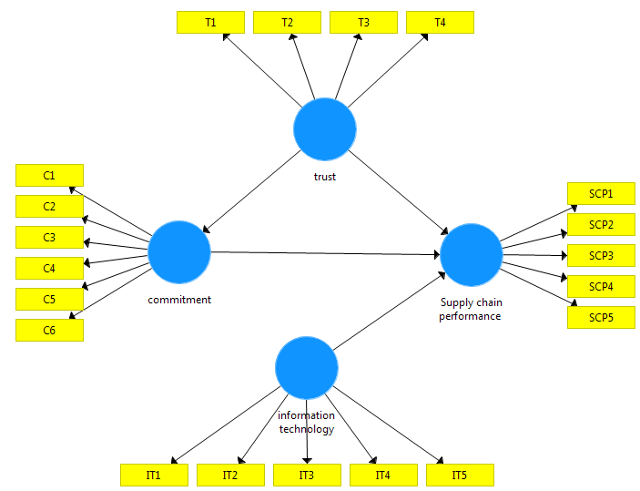
Fig 1. Research Model
The hypotheses in this study are:
H1: There is a significant relationship between Trust and SMEs Supply Chain Performance
H2: There is a significant relationship between Trust and SMEs Commitment
H3: There is a significant relationship between Commitment and Supply Chain Performance
H4: There is a significant relationship between Information Technology and SMEs supply chain

- Result and Discussion

3.1 Convergent validity
Each indicator’s validity to its latent variable is assessed using convergent validity, and in the SmartPLS program, the outer loading table shows the validity results. There are numbers or values in the outer loading table that serve as markers of similarities to the construct variables. If the indicator describes the build variable with a value greater than 0.7, the value is considered valid [12]. From Figure 2 it can be seen that the charge value of all indicators has met the requirements, namely more than 0.70 and it has been said that all indicators are valid.
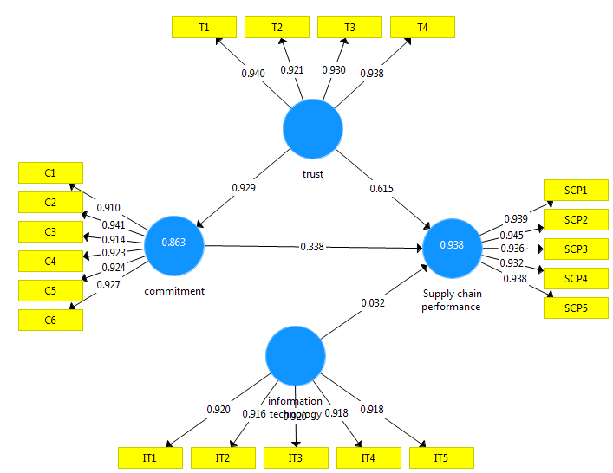
Fig 2. Validity Test

3.2 Reliability Test / Composite Reliability
The purpose of the reliability test in this study is to evaluate how trustworthy or dependable the measurement tools utilized in this investigation are. The composite reliability shows the results of the reliability test. Composite reliability measures how reliable a construct’s indications are. If the composite reliability and Cronbach’s alpha value are both above 0.70, a construct is deemed reliable [13]. Table 1 shows that the AVE value is greater than 0.5, indicating that all constructs are legitimate or that the construct can account for the item variance.
Table 1. Reliability Test / Composite Reliability
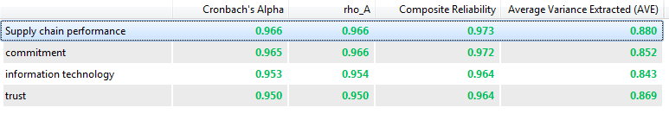
The purpose of the reliability test in this study is to evaluate how trustworthy or dependable the measurement tools utilized in this investigation are. The composite reliability shows the results of the reliability test. Composite reliability measures how reliable a construct’s indications are. If the composite reliability and Cronbach’s alpha values are both more than 0.70, the construct is deemed [14]. Table 1’s findings indicate that the composite reliability value and Cronbach’s alpha are both greater than 0.70. Thus, it can be said that the employed questionnaire is reliable and consistent.
3.3 Coefficient of determination (R2)

The structural model (inner model) is further tested by examining the coefficient of determination (R2) and the path coefficient when the computed model passes the criteria for discriminant validity. The exogenous construct’s ability to explain the endogenous construct is measured using the coefficient of determination. Additionally, the path coefficient seeks to evaluate the hypothesis as well as determine the importance and strength of the link. The R-square value of 0.75 indicates a strong model, 0.50 indicates a moderate model, and 0.25 indicates a strong model. Figure 2 shows that the usage variable suggests that user satisfaction is strong and that the research value is moderate, indicating that it is very necessary to do user satisfaction research. The R-square value for commitment is 0.867, which indicates that trust has an influence of 86.7 percent while other variables not covered in this study have an influence on the remaining 13.7 percent. The supply chain performance R-square value is 0.938, which indicates that trust, commitment, and information technology influence 93.8 percent of the supply chain performance, with the remaining 6.2 percent influenced by additional variables not covered in this study.
3.4 Hypothesis testing
To ascertain whether there is a relationship between the variables, compare the t count with the t table. The results of bootstrapping with the Smart PLS program are used to calculate the t value. Bootstrap testing tries to lessen the issue of aberrant research data. The t-statistic value was utilized in this study to test the hypothesis, and it was set at 1.96 for a value of =5%. As a result, when the t-statistic is greater than 1.96, the hypothesis is accepted as Ha and rejected as H0. In order to evaluate hypotheses, the bootstrap resampling findings’ output path coefficient is examined as follows:
Table 2. Hypothesis testing
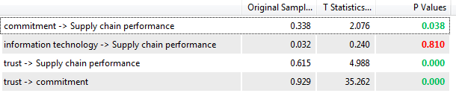
3.5 Trust and SMEs Supply Chain Performance

A path coefficient value of 0.615, a p-value of 0.000, and a T-statistic value of 4,988 (T-statistic >T table 1.96) indicate that trust has an impact on SMEs’ supply chain performance. It can be said that hypothesis 1 is supported because it demonstrates that trust affects SMEs’ supply chain performance. T-statistics > T-table 1.96, which means that the value of T-statistics satisfies the criteria.

3.6 Trust and SMEs Commitment

Trust and SMEs Commitment has a path coefficient of 0.929, a p-value of 0.000, a T-statistic of 35.262 (T-statistic T table 1.96), and a p-value of 0.000. Hypothesis 2 can be said to be supported, demonstrating that Trust affects Commitment. T-statistics > T-table 1.96, which means that the value of T-statistics satisfies the criteria.

3.7 Commitment and Supply Chain Performance

Commitment and Supply Chain Performance has a path coefficient of 0.338, a p-value of 0.038, and a T-statistic of 20.76 (T-statistic T table 1.96). It also has a p-value of 0.03 and a p-value of 0.038. It can be said that hypothesis 2 is supported because it demonstrates how commitment affects supply chain performance. T-statistics > T-table 1.96, which means that the value of T-statistics satisfies the criteria.

3.8 Information Technology and SMEs supply chain

A path coefficient value of 0.032, a p-value of 0.810, and a T-statistic value of 0.240 are provided by information technology and SMEs supply chain (T-statistic T table 1.96). The rejection of hypothesis 4 demonstrates that information technology has no appreciable impact on supply chain performance. Because the value of T-statistics, T-statistics T-table 1.96, satisfies the criteria.

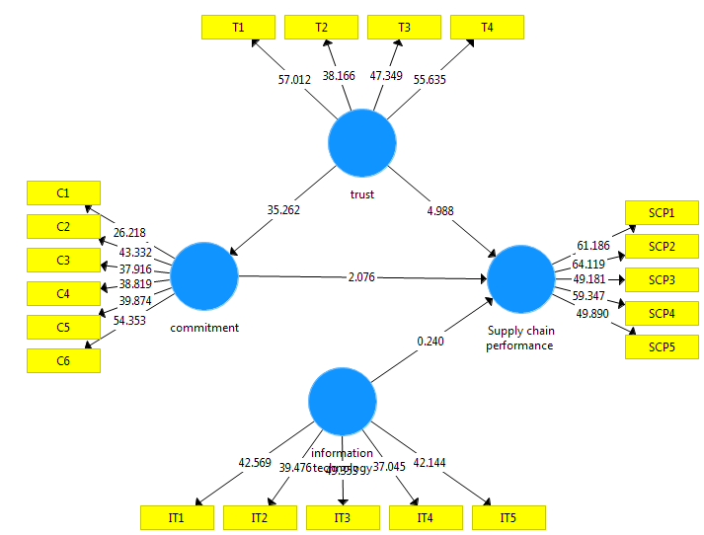
Fig 3. Hypothesis Testing

3.9 The Effect of Trust on SMEs’ Supply Chain Performance

A path coefficient value of 0.615, a p-value of 0.000, and a T-statistic value of 4,988 (T-statistic >T table 1.96) indicate that trust has an impact on SMEs’ supply chain performance. It can be said that hypothesis 1 is supported because it demonstrates that trust affects SMEs’ supply chain performance. T-statistics > T-table 1.96, which means that the value of T-statistics satisfies the criteria. These findings suggest that the trust variable has a substantial impact on supply chain performance, which is recognized or supported by empirical evidence. The direction of influence is positive and significant, therefore greater trust among supply chain participants may result in improved performance. The findings of this investigation support the following A number of studies, including those by [8]–[11], have demonstrated a correlation between trust and supply chain performance. [15] demonstrates that the key element in supply chain member participation is trust. According to [16], in light of this finding, [17] stated that one of the crucial components that must exist and develop in a supply chain system is trust among supply chain participants. Additionally, this study’s findings contradict those of [18], [19], which found no connection between commitment and trust.

3.10 The Effect of Trust on SMEs Commitment

Trust and SMEs Commitment has a path coefficient of 0.929, a p-value of 0.000, a T-statistic of 35.262 (T-statistic T table 1.96), and a p-value of 0.000. Hypothesis 2 can be said to be supported, demonstrating that Trust affects Commitment. T-statistics > T-table 1.96, which means that the value of T-statistics satisfies the criteria. These findings show that the trust variable significantly affects a person’s willingness to accept or endorse empirical evidence. The direction of impact has a considerable and positive value, therefore greater trust among supply chain participants may result in greater commitment. The results of this study corroborate the statements made by [4], [20]–[22] that commitment is a function of trust. Trust is crucial for fostering commitment and for boosting collaboration. Companies that have confidence in their partners’ honesty are more likely to want to cooperate with them in the future. The fundamental elements supporting the company’s supplier relationships are commitment and trust. The findings of this study simultaneously support and add weight to those of [20], [22] that building trust results in a strong commitment to all supply chain participants.

3.11 The Effect of Commitment on SMEs’ Supply Chain Performance

Commitment and Supply Chain Performance has a path coefficient of 0.338, a p-value of 0.038, and a T-statistic of 20.76 (T-statistic T table 1.96). It also has a p-value of 0.03 and a p-value of 0.038. It can be said that hypothesis 2 is supported because it demonstrates how commitment affects supply chain performance. T-statistics > T-table 1.96, which means that the value of T-statistics satisfies the criteria. The p value 0.000 0.050 indicates that the commitment variable has a direct impact on supply chain performance. Based on these findings, it can be said that the commitment variable significantly affects supply chain performance. The direction of influence has a considerable and positive value, therefore a higher commitment among supply chain participants may result in improved performance. The results of this study concur with and corroborate those of [1], [3], [4], [23], who found that a strong developing commitment boosts supply chain performance. The descriptive analysis’s findings demonstrate that the continuing commitment indicator, which has the greatest perception and a factor weight value of 0.897 and a mean value of 4.11, is a crucial indication in determining the commitment variable. In light of this discovery, [22] make the claim that continuation commitment pertains to each individual’s active and ongoing involvement in the supply chain to decide on all activities for enhancing the performance of all supply chain members. [20] support this claim.

  - The Effect of Information Technology on SMEs’ Supply Chain Performance

A path coefficient value of 0.032, a p-value of 0.810, and a T-statistic value of 0.240 are provided by information technology and SMEs supply chain (T-statistic T table 1.96). The rejection of hypothesis 4 demonstrates that information technology has no appreciable impact on supply chain performance. Because the value of T-statistics, T-statistics T-table 1.96, satisfies the criteria. The p value of 0.000 0.050 indicates that information technology variables have a direct impact on supply chain performance. These findings suggest that supply chain performance is significantly influenced by information technology characteristics, which is recognized or confirmed by empirical data. A more effective use of information technology may result in improved supply chain performance, according to the direction of influence, which has a positive and significant value. Information technology (IT) is one of the primary facilitators of supply chain strategic advantage, according to [1]–[4], [21], [23], [24]. The effectiveness of the flow of products, information, and money can be increased by using effective coordination mechanisms between supply chain participants via online information networks. Collaboration capabilities are supported in large part by information sharing. Additionally, it backs up the assertions made by [1]–[4], [23] that IT implementation is widely regarded as a key element in the success of supply chain management and is essential for maximizing supply chain performance. The constant advancement of information technology supports its incorporation into supply chain management, which can boost a company’s productivity and profitability. Information technology can improve opportunities in supply chain areas like information exchange, coordination, integration, and sensitive activities and helps to promote cooperation and coordination in the supply chain. The evidence from [4], [20]–[22] supports the idea that supply chain performance can be enhanced through supplier integration with the help of information technology.

3.13 Managerial Implications
The findings of this study have significance for the crucial role that management plays in establishing and upholding commitment and trust among all participants in the supply chain system. In order to attain optimal performance, the supply chain system urgently needs to use information technology. More flexibility and a company’s dependability in meeting client needs will be the hallmarks of improved supply chain performance. The performance of SMEs’ supply chains will be improved through the application of information technology, trust, and dedication. This can be shown in improving product delivery (on-time delivery), falling operating costs, and optimal utility in SMEs’ operations or production processes.
- Conclusion

The study’s findings indicate that trust influences commitment, commitment influences supply chain performance for SMEs, and commitment influences supply chain performance. Information technology has no discernible impact on supply chain performance. Better SMEs supply chain performance may result from increased trust among supply chain participants. Members of the supply chain may be more committed as a result of greater trust. Better supply chain performance may be the result of strong dedication. Additionally, improved information technology use may result in improved supply chain performance. In order to maximize the performance of the supply chain, IT installation is typically seen as essential to the success of supply chain management. Through commitment, the trust factor has a considerable impact on supply chain performance. In terms of enhancing supply chain performance, the indirect effect of the trust variable through commitment is stronger than the direct effect. Compared to trust and commitment, the usage of information technology has a greater impact on supply chain performance indicators. The management of SMEs must fully appreciate how crucial it is to foster commitment and trust among all participants in the supply chain. In addition, businesses now heavily rely on the usage of SMEs information technology to manage and enhance supply chain performance. Prior to enhancing supply chain performance, all supply chain participants should put forth intense, deliberate, and ongoing effort to develop and grow mutual trust and commitment. Supply chain performance will increase as a result of a mix of trust, dedication, and greater IT assistance. The findings of this study have repercussions for the crucial role that management plays in upholding commitment, trust, and information technology use in the supply chain system. More adaptable and dependable SMEs will be able to better meet customer requests, which will result in improved supply chain performance. Additionally, at the same time, operational expenses are decreasing, product delivery performance is improving, and utility in the operating process is at its highest level. It is advised to include variables, a larger research region, and different sorts of SMEs businesses to provide a wider generalization of the findings for the benefit of future research.
References
[1] R. Rudyanto, L. Soemarni, R. Pramono, and A. Purwanto, “Management The influence of antecedents of supply chain integration on company performance,” Uncertain Supply Chain Management, vol. 8, pp. 1–10, May 2020, doi: 10.5267/j.uscm.2020.5.006.
[2] J. Rezaei, R. Ortt, and P. Trott, “How SMEs can benefit from supply chain partnerships,” Int J Prod Res, vol. 53, no. 5, pp. 1527–1543, Mar. 2015, doi: 10.1080/00207543.2014.952793.
[3] E. N. Tan, G. Smith, and M. Saad, “Managing the global supply chain:a SME perspective,” Production Planning & Control, vol. 17, no. 3, pp. 238–246, Apr. 2006, doi: 10.1080/09537280500285417.
[4] M.-L. Tseng, K.-J. Wu, and T. T. Nguyen, “Information technology in supply chain management: a case study,” Procedia Soc Behav Sci, vol. 25, pp. 257–272, 2011, doi: 10.1016/j.sbspro.2011.10.546.
[5] M. Colin, R. Galindo, and O. Hernández, “Information and Communication Technology as a Key Strategy for Efficient Supply Chain Management in Manufacturing SMEs,” Procedia Comput Sci, vol. 55, pp. 833–842, 2015, doi: https://doi.org/10.1016/j.procs.2015.07.152.
[6] M. Mohammad Bagheri, A. Abdul, I. Soltani, A. Mardani, and E. Kish Hazrat Soltan, “The Role of Supply Chain Antecedents on Supply Chain Agility in SMEs: The Conceptual Framework,” J Teknol, vol. 66, pp. 53–60, Jan. 2014, doi: 10.11113/jt.v66.1826.
[7] M. Basheer, M. Siam, A. Awn, and S. Hassan, “Exploring the role of TQM and supply chain practices for firm supply performance in the presence of information technology capabilities and supply chain technology adoption: A case of textile firms in Pakistan,” Uncertain Supply Chain Management, vol. 7, pp. 275–288, Jan. 2019, doi: 10.5267/j.uscm.2018.9.001.
[8] D. I. Kusuma and D. Soediantono, “How The Role of Supplier Integration, Manager Transformational Leadership on Supply Chain Performance in Defense Industries?,” Journal of Industrial Engineering &amp; Management Research, vol. 3, no. 3, pp. 98–110, Feb. 2022, doi: 10.7777/jiemar.v3i3.290.
[9] H. J. Kim, “Information technology and firm performance: the role of supply chain integration,” Operations Management Research, vol. 10, no. 1, pp. 1–9, 2017, doi: 10.1007/s12063-016-0122-z.
[10] J. Gumboh and R. Gichira, “Supply Chain Collaboration among SMEs in Kenya: A Review of Collaboration Barriers,” 2015.
[11] M. Hudnurkar, S. Jakhar, and U. Rathod, “Factors Affecting Collaboration in Supply Chain: A Literature Review,” Procedia Soc Behav Sci, vol. 133, pp. 189–202, 2014, doi: https://doi.org/10.1016/j.sbspro.2014.04.184.
[12] A. Purwanto, M. Asbari, and T. Santoso, “Education Management Research Data Analysis: Comparison of Results between Lisrel, Tetrad, GSCA, Amos, SmartPLS, WarpPLS, and SPSS For Small Samples,” Nidhomul Haq : Jurnal Manajemen Pendidikan Islam, vol. 6, no. 2, Aug. 2021, doi: 10.31538/ndh.v6i2.1575.
[13] Agus Purwanto and Yuli Sudargini, “Partial Least Squares Structural Squation Modeling (PLS-SEM) Analysis for Social and Management Research : A Literature Review,” Journal of Industrial Engineering & Management Research, vol. 2, no. 4, pp. 114–123, 2021.
[14] A. Purwanto, M. Asbari, and T. I. Santoso, “Education Management Research Data Analysis: Comparison of Results between Lisrel, Tetrad, GSCA, Amos, SmartPLS, WarpPLS, and SPSS For Small Samples,” Nidhomul Haq : Jurnal Manajemen Pendidikan Islam, vol. 6, no. 2, pp. 382–399, Aug. 2021, doi: 10.31538/ndh.v6i2.1575.
[15] M. Mamad and F. O. Chahdi, “The Factors of the Collaboration between the Upstream Supply Chain Actors: Case of the Automotive Sector in Morocco,” International Business Research, vol. 6, p. 15, 2013.
[16] N. Pfanelo, “ Supply chain partnership, collaboration, integration and relationship commitment as predictors of supply chain performance in South Africa SMEs,” Business &amp; Social Sciences Journal, vol. 2, no. 1, pp. 134–168, 2017, doi: 10.10520/EJC-933defd81.
[17] D. Pooe, C. Mafini, and V. W. Loury-Okoumba, “The influence of information sharing, supplier trust and supplier synergy on supplier performance: The case of small and medium enterprises,” Journal of Transport and Supply Chain Management, vol. 9, no. 1, Feb. 2015, doi: 10.4102/jtscm.v9i1.187.
[18] A. Harits, N. Man, L. Nurwandi, I. Bachtiar, T. Aspiranti, and I. Pratama, “Social Networking, and Firm Performance: Mediating Role of Comparative Advantage and Sustainable Supply Chain,” Jun. 2020.
[19] S. Li and B. Lin, “Accessing information sharing and information quality in supply chain management,” Decis Support Syst, vol. 42, no. 3, pp. 1641–1656, 2006, doi: https://doi.org/10.1016/j.dss.2006.02.011.
[20] W. W. Willette, J. T. C. Teng, and A. Singh, “Journal of Information Technology Management SHAPING ASYMMETRIC SUPPLY CHAIN PARTNERSHIPS: THE ROLE OF SHARED IT AND TRUST,” Journal of Information Technology Management, vol. XXVII, no. 1, 2016.
[21] A. Valenzuela and O. Contreras, “Trust and Innovation: Small and Medium Enterprises within Global Value Chains in Northern Mexico,” Journal of Small Business and Entrepreneurship Development, vol. 2, Jan. 2014, doi: 10.15640/jsbed.v2n3-4a4.
[22] G. Welker, T. Vaart, and D. P. Van Donk, “The influence of business conditions on supply chain information-sharing mechanisms: A study among supply chain links of SMEs,” Int J Prod Econ, vol. 113, pp. 706–720, Jun. 2008, doi: 10.1016/j.ijpe.2007.04.016.
[23] S. Suharto, I. W. R. Junaedi, H. M. Muhdar, A. Firmansyah, and S. Sarana, “Consumer loyalty of Indonesia e-commerce SMEs: The role of social media marketing and customer satisfaction,” International Journal of Data and Network Science, vol. 6, no. 2, pp. 383–390, 2022, doi: 10.5267/j.ijdns.2021.12.016.
[24] A. I. Permana and D. Soediantono, “The Role of Eco Supply Chain on Environment and Operational Performance of Indonesian Defense Industry,” Journal of Industrial Engineering &amp; Management Research, vol. 3, no. 3, pp. 73–84, Feb. 2022, doi: 10.7777/jiemar.v3i3.284.

