CONCLUSION
FINAL EXAM PRESENTATION OF THESIS
_____________________________________________________________________________________

We the undersigned confirmed that on this day, Wednesday, December 14, 2022 we have conducted the final exam presentation of Thesis:

20221005 | Huger Dhanu Anggoro
Thesis Title: The Effect of Perceived Value, Service Quality, and Reputation to Customer Loyalty on Independent Automotive Workshop in DKI Jakarta: Trust as Moderator.

After reviewing during the Final Presentation in front of Examiner, we conclude that this Thesis Final Presentation is: *) ( V ) PASS .
( ) NOT PASS.
Note: *) please tick (V).

Jakarta, Wednesday, December 14, 2022
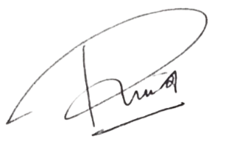

Ir. Yulita Fairina Susanti, M.Sc, Ph.D  Chairperson of Board Examiner | Dr. Rima Agristina  Mentor 1 | Assoc Prof Dr Leonnard Ong, S.E, M.Com, CDM  Mentor 2 | Prof. Ir. Dedi Fardiaz, Ph.D  Examiner

