Attendance List
Thesis Final Presentation

________________________________________________________________
Day/Date : Tuesday,December 20, 2022
Program : Graduate Program (Executive September 2019)
No. | Name of Examiner | Remarks | Signature
1. | Ir. Yulita Fairina Susanti, M.Sc, Ph.D | Chairperson of Board ( Examiner-1) | 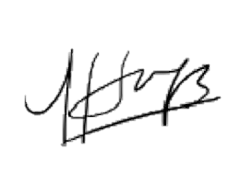  1.
2. | Dr. Amelia Naim Indrajaya, MBA | Mentor (Examiner -2) | 2.
3. | Bernardus Agus Finardi, SE., MSM. | Mentor 2 (Examiner -3) | 3.
4. | Eka Sri Dana Afriza, S.Sos, M.M. | Examiner - 4 | 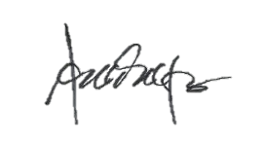  4.

Students:
No. | Student ID | Name of Student | Signature
1. | 19222031 | Kim Min Suk | 1.

