Lampiran 1. Format Biodata Pengusul/Anggota Tim Pelaksana
A. Identitas Diri

1 | Nama Lengkap (dengan gelar) | Dr. Ir. Amelia Naim Indrajaya, MBA
2 | Jenis Kelamin | Perempuan
3 | Jabatan Fungsional | Lektor
4 | NIP/NIK/Identitas lainnya | 13030104
5 | NIDN | 0316066503
6 | Tempat dan Tanggal Lahir | New York, USA, 19-Juni-1965
7 | E-mail | amelia.naim@ipmi.ac.id
8 | Nomor Telepon/HP | +62 818 924 263 / +62 813 819 59360
9 | Alamat Kantor | Jl. Rawajati Timur I/1 Kalibata Jakarta Selatan 12750
10 | Nomor Telepon/Faks | (62-21) 797 8888 / (62-21) 797 0509
11 | Lulusan yang Telah Dihasilkan | S-1 = 50 orang; S-2 = 60 orang; S-3 = 0 orang
12. Mata Kuliah yg Diampu |  | 1 Business Ethics
 |  | 2 Good Corporate Governance
 |  | 3 Spiritual Management
 |  | 4 Strategic Management

B. Riwayat Pendidikan

 | S-1 | S-2 | S-3
Nama Perguruan Tinggi | Institut Teknologi Bandung | University of Colorado at Boulder | Universitas Indonesia
Bidang Ilmu | Industrial Management | Management | Strategic Management
Tahun Masuk-Lulus | 1983 - 1988 | 1990 - 1991 | 2012 - 2016
Judul Skripsi/Tesis/Disertasi | Increasing HR Productivity in Telkom | Productivity and Management | Spirit at Work and Competitive Advantage
Nama Pembimbing/Promotor | Prof Dr Mathias A. |  | Prof. Adi Zakaria

C. Pengalaman Penelitian Dalam 5 Tahun Terakhir
(Bukan Skripsi, Tesis, maupun Disertasi)

No. | Tahun | Judul Penelitian | Pendanaan
 |  |  | Sumber* | Jumlah  (Juta Rp)
1. | 2017-2018 | Proposed Improvement Strategy for PT Sari Melati Kencana (SMK) by Using Lean Six Sigma | PT. Sriboga Raturaya & PT. Sarimelati Kencana | 610
2. | 2018 | The Interaction of Spiritual Leadership and Individual Spirituality impacting Spirit at Work toward Enhancing Organizational Commitment and Job Satisfaction: A Conceptual Proposition | DIKTI | 122,5
3. | 2018 | Spiritual Development Programs, Individual Spirituality and Sustainability Mindset toward Higher Commitment to Social and Environmental Impact | Pribadi | 50
4. | 2019 | The Interaction of Individual Spirituality and Spiritual Leadership toward Spirit at Work as Intangible  Resource Capabilities in the Resource Based View Framework: A Comparative case of Indonesia vs Hong Kong | DIKTI | 95,25
5. | 2019 | The Impact Of Applying Mindfulness And Sustainability Mindset: An Explorative Study In Ipmi Business School | Pribadi | 30
6. | 2019 | Developing Sustainability Mindset through Experiential Learning Spiritual Development Phases in Business School | Pribadi | 40
7. | 2019 | Spirit at Work and Anti Corruption Culture | Pribadi | 30
8. | 2022 | The Effect Of Big Five Model (Bfm) Personality Traits On Online Impulsive Buying: Evidence From Website User In Dki Jakarta Area | Pribadi | 20
* Tuliskan sumber pendanaan baik dari skema penelitian DIKTI maupun dari sumber lainnya.
D. Pengalaman Pengabdian Kepada Masyarakat dalam 5 Tahun Terakhir

No. | Tahun | Judul Pengabdian Kepada Masyarakat | Pendanaan
 |  |  | Sumber* | Jumlah  (Juta Rp)
1 | 2018 | Meningkatkan Pemahaman Siswa Terhadap Konsep Bhineka Tunggal Ika | IPMI | 4,51
2 | 2018 | Mengembangkan Usaha Home Industry dengan Teknik Decoupage | IPMI | 1,26
3 | 2018 | Mengoptimalkan Potensi Guru Dan Penyusunan Program Pengembangan Masyarakat Mentawai | IPMI | 4,48
4 | 2018 | Pendampingan Pengembangan Desa Wisata Situ Tasikardi melalui Pemberdayaan BUMDes Margasana | IPMI | 4
5 | 2018 | Pengembangan Komunitas Masyarakat Desa Margasana mengenai Kemampuan Pemasaran Digital | IPMI | 2,54
6 | 2018 | Pendampingan Pengembangan Tanaman Hidroponik di Desa Margasana untuk Kehidupan yang Lebih Sehat dan Sejahtera | IPMI | 3,85
7 | 2018 | Penumbuhan Kreatifitas melalui Seni Keterampilan Makrame dan Strategi Penjualan Online Guna Meningkatkan Jiwa Kewirausahaan Remaja Putri di Panti Asuhan Darush Sholihat Bogor Jawa Barat | IPMI | 6,25
8 | 2018 | Pembinaan Kader Konservasi Taman Nasional Kepulauan Seribu, Pulau Kelapa Dua melalui Kegiatan Pelatihan dengan Tema "Hospitality" | IPMI | 1,5
9 | 2018 | Revitalisasi Proyek "Green House" Pelatihan Pembuatan Jamu dengan Memanfaatkan Tanaman Obat | IPMI | 1,92
10 | 2019 | Peningkatan Pendapatan Kelompok Produsen Makanan Berbahan Baku Lokal Melalui Pelatihan Dan Pendampingan E-Commerce Dan Akuntansi Di Pulau Kelapa Dua | IPMI | 2
11 | 2019 | Kegiatan Bakti Sosial untuk Membantu Korban Banjir di Kelurahan Rawajati, Kecamatan Pancoran, Jakarta | IPMI dan Lainnya dlm Negri | 22,73
12 | 2019 | Pelatihan Pemanfaatan Sampah Plastik dan Keterampilan Membuat Souvenir dari Bahan Daur Ulang untuk Anak dan Remaja Kelurahan Cempaka Putih, Kecamatan Ciputat Timur | IPMI dan Lainnya dlm Negri | 12,625
13 | 2019 | Pendidikan untuk Mengembangkan Kreatif, Inovatif Bisnis yang Berkelanjutan dan Berkelimpahan dan Mendukung Sustainable Development Goals dari PBB | IPMI dan Lainnya dlm Negri | 5,21
14 | 2019 | Membangun Karakter dan Integritas Pemuda dan Pemudi Harapan Bangsa | Pribadi | 10
15 | 2019 | Penyuluhan "Inovasi Berkelanjutan" | Pribadi | 10
16 | 2019 | Dialog Interaktif Munas III Ikatan Alumni SMP 1 Bukittinggi dengan tema "Minakabau Bangkit" | Ikatan Alumni SMP 1 Bukittinggi | 10
17 | 2020 | Menjadi Pelatih yang Menginspirasi | Pribadi | 5
18 | 2020 | Unleashing the Utmost Potential in You | IPMI | 2
19 | 2020 | Webinar "Millenials as Change Makers" | IPMI | 1
20 | 2020 | Strategi Penelitian Penerapan Ideologi Pancasila dan Pengabdian Masyarakat untuk UMKM | IPMI | 0,3
21 | 2020 | Strategi Abdimas UMKM | Pribadi | 1,5
22 | 2020 | UMKM Tangguh Hadapi Pandemik | Pribadi | 1,5
23 | 2020 | The Future of Sustainability 2: The Head, The Heart, and The Hand | Pribadi | 5
24 | 2020 | Peran HRD dan Karyawan dalam Menghadapi Krisis Pandemi Covid-19: Bantu Sesama dengan Menyehatkan Diri Kita | IPMI | 5
25 | 2020 | Webinar “Next Generation Governance" | IPMI | 1
26 | 2021 | Pemutakhiran Alat Ukur UMKM bersama BPIP | BPIP | 90
27 | 2021 | Pancasila dalam Tindakan, Bangga Produk UMKM Indonesia | Pribadi | 5
28 | 2021 | Youth Time International Movement: Be A Changemaker and support the Sustainable Development Goals of the UN, 2021 | Pribadi | 5
29 | 2021 | Pendampingan dan Coaching Inovasi Bisnis dan Manajemen Indonesia Power 2021 | Indonesia Power | 7,5
30 | 2021 | Workshop Pengembangan Karakter Mengantisipasi Dampak Negatif Globalisasi | IPMI dan Lainnya dlm Negri | 2
31 | 2022 | Workshop pengembangan karakter: Mendidik Dengan Multiple Intelligence (Intellectual, Emotional dan Spiritual Intelligence) | IPMI dan Lainnya dlm Negri | 3,5
* Tuliskan sumber pendanaan baik dari skema pengabdian kepada masyarakat DIKTI
maupun dari sumber lainnya.

E. Publikasi Artikel Ilmiah Dalam Jurnal alam 5 Tahun Terakhir

No. | Judul Artikel Ilmiah | Nama Jurnal | Volume/ Nomor/Tahun
1 | Spiritual Development Programs, Individual Spirituality and Sustainability Mindset toward Higher Commitment to Social and Environmental Impact | International Journal of Business Studies | Vol. 2/No. 3/2018
2 | The Interaction of Spiritual Leadership and Individual Spirituality impacting Spirit at Work toward Enhancing Organizational Commitment and Job Satisfaction: A Conceptual Proposition | Journal of Law and Society Management | Vol. 6/No. 1/ 2019
3 | PT. DNX Indonesia: The Importance of Service Quality in Indonesian Mining Industry | South East Asia Journal of Business, Economics and Law | Vol. 19/No. 2/2019
4 | Discovering Adoption of Agile Management Paradigm in Software Development at PT. Asuransi Allianz Life Indonesia | South East Asia Journal of Business, Economics and Law | Vol. 19/No. 2/2019
5 | The Role of Human Resource Management in the Success of the Engineering, Procurement & Construction and Operation Maintenance Projects at PT Elnusa Tbk | International Journal of Business, Economics and Law | Vol. 19/No. 2/2019
6 | The Conceptual Model of Spiritual Leadership and Spirit at Work in Creating A Sustainable Competitive Advantage | International Journal of Business, Economics and Law | Vol. 19/No. 2/2019
7 | Biogas Business Modelling Using Business Model Canvas Approach With Blue Ocean Strategy | Journal of Adult Education and Lifelong Learning | Vol. 1/2019
8 | Industrial Biogas Project Validation Planning: Strategic Business Initiation Using Benefit Measurement Approach | Journal of Adult Education and Lifelong Learning | Vol. 1/2019
9 | Leveraging Social Enterprise As A Sustainable Corporate Social Responsibility Model: Case Study At Perusahaan Gas Negara, Indonesia | Journal of Adult Education and Lifelong Learning | Vol. 1/2019
10 | The Impact Of Applying Mindfulness And Sustainability Mindset: An Explorative Study In Ipmi Business School | Journal of Adult Education and Lifelong Learning | Vol. 1/2019
11 | Professional Perception On Formulating Green Marketing Plan In Biogas Project | Journal of Adult Education and Lifelong Learning | Vol. 1/2019
12 | Spirit at Work and Anti Corruption Culture | Journal of Adult Education and Lifelong Learning | Vol. 1/2019
13 | Developing Sustainability Mindset through Experiential Learning Spiritual Development Phases in Business School | Journal of Business Studies, Special International Edition | Vol. 3/No. 1/2019
14 | The Relation Of Organization Culture And Company Strategy For Sustaining Competitive Advantage At Pt. Dekatama Centra | International Journal of Business, Economics and Law | Vol. 19/No. 2/2019
15 | Discovering The Impact Of Spirituality At Work Toward Job Performance: Case Of Pt Surya Nusantara Sentosa | International Journal of Business, Economics and Law | Vol. 19/No. 2/2019
16 | Indonesian Patronage Intention Toward E-Commerce | South East Asia Journal of Business, Economics and Law | Vol. 19/No. 2/2019
17 | The Impact of Spiritual Leadership and Spirit at Work as Intangible Resource Capabilities toward Job Satisfaction and Organizational Commitment: A Comparative Study of Indonesia vs Hong Kong | International Journal of Psychosocial Rehabilitation | Vol. 24/No. 6/2020
18 | The Effect Of Big Five Model (Bfm) Personality Traits On Online Impulsive Buying: Evidence From Website User In Dki Jakarta Area | International Journal of Business, Economics and Law | Vol. 26/No. 1/2022
19 | The Integrated Approach Of Spiritual Development Phase In Developing Sustainability Mindset: A Case Study Of Ipmi International Business  School | South East Asia Journal of Contemporary Business, Economics and Law | Vol. 26/No. 1/2022
20 | Social Media Marketing Activities Of Creative Agencies In Indonesia And Its Influence On Customer Equity And Purchase Intention: Evidence  From Kanō Creative Production | International Journal of Business, Economics and Law | Vol. 26/No. 1/2022
21 | Effect Of Company Organisation Factors On Employee Perceived Productivity During Working From Home | South East Asia Journal of Contemporary Business, Economics and Law | Vol. 26/No. 1/2022

F. Pemakalah Seminar Ilmiah (Oral Presentation) dalam 5 Tahun Terakhir

No | Nama Pertemuan Ilmiah / Seminar | Judul Artikel Ilmiah | Waktu dan  Tempat
1 | Academy of Management Meeting, Chicago, USA | Improving Student Lives Through International Teaching Collaborations | 10 – 14 Agustus 2018, Chicago Amerika Serikat
2 | Third International Conference on Business and Economics | The Importance of Spiritual Leadership variables and Spirit at Work as Intangible Resource Capabilities in the Service Industry: A Resource Based View Framework | 9 – 10 Oktober 2018, University of Dhaka Bangladesh
3 | International Conference "Business and Management Sciences: New Challenges in Theory and Practice" | The Importance of Workplace Spirituality toward Enhancing Organizational Commitment and Job Satisfaction: A Conceptual Work | 25 -26 Oktober 2018, Szent Istvan University, Godollo, Hungaria
4 | 2018 International Conference on Adult Education and Lifelong Learning (AdELL 2018) | Biogas Business Modelling By Business Model Canvas Approach With Blue Ocean Strategy | 6 -7 Desember 2018, The Savoy Hotel Manila Filipina
5 | 2nd International Conference on Law and Society Management | Resource based view model of Spiritual Leadership and Spirit at Work toward Competitive advantages in the Service Industry | 12 – 13 Februari 2019, Istanbul Turki
6 | EURAM 2019 | Spiritual Diversity Training Programs Improving Organizational Performance: An Indonesian Case Study | 26 – 28 Juni 2019, Lisboa Portugal
7 | Academy of International Business - Africa | Spirit at Work and Anti Corruption | 6 – 9 Januari 2020, Nairobi Kenya
8 | American International University, Nairobi Kenya | How to develop a publishable paper of community engagement | 10 Januari 2020, Nairobi Kenya
9 | International Conference on Consciousness-Based Leadership and Management | The Importance of Spiritual Leadership and Spirit at Work as Intangible Resource Capabilities in the Service Industry: A Resource Based View Framework | 21 – 23 Mei 2021, Online
10 | 2021 International CEO Communication, Economics, Organization & Social Sciences Congress | The Effects of COVID -19 Outbreak on Higher Education in Indonesia | 19 – 22 Agustus 2021, Online
11 | 3rd International CEO and Social Sciences Congress (CEOSSC) | Developing Sustainability Mindset through Spirituality Development Phases in Business and Management Education: The Evidence from IPMI International Business School | 24 – 25 Desember 2021, Online
12 | International Conference “International CEO Communication, Economics, Organization & Social Sciences Congress” 2022 | Creating Shared Values toward Enhancing Company’s Performance: An Evidence from IPMI’s MBA Students’ Experience | 20 – 22 Mei 2022, Online
13 | International Conference “International CEO Communication, Economics, Organization & Social Sciences Congress” 2022 | Behavioral Intention to Use LMS Using Technology Acceptance Model an Empirical Study In STM-IPMI | 20 – 22 Mei 2022, Online

G. Karya Buku dalam 5 Tahun Terakhir

No | Judul Buku | Tahun | Jumlah  Halaman | Penerbit
1 | Developing a Sustainability Mindset in Management Education (Chapter: Enhancing the sustainability mindset through real life business as a flourishing impact project) | 2018 | 18 | Taylor & Francis
2 | Spirit at Work: The Telkom Experience of Great Spirit Grand Strategy | 2019 | 30 | Putra Media Nusantara
3 | Kiat menjadi pembicara yang menginspirasi | 2020 | 95 | AMNA
4 | The Palgrave Handbook of Corporate Social Responsibility (Chapter: Employee Volunteering) | 2020 | 28 | Palgrave
5 | Journey to Transform Students into Implementing the Sustainability Mindset: A Case of Sekolah Tinggi Manajemen Ipmi (Ipmi International Business School. Handbook for Personal and Organizational Transformation) | 2020 | 68 | Springer
6 | My Spiritual Commitment as A Change Maker | 2020 | 455 | AMNA
7 | Handbook of Personal and Organizational Transformation (Chapter: A journey to transform students into Implementing the Sustainability Mindset: A Case of IPMI International Business School) | 2021 | 40 | AMNA
8 | Disruptive Innovation: Terobosan Stratejik dari Multi Aspek | 2021 | 137 | Penerbit Widina
9 | Sustainability Mindset Discovery Learning: A Case Study of IPMI International Business School | 2021 | 184 | AMNA
10 | A Letter to My Unborn Child | 2021 | 215 | AMNA
11 | Anti-corruption agent : IPMI students' journey against corruption | 2021 | 79 | AMNA
12 | Creating sustainability through talent management improvement | 2021 | 112 | AMNA
13 | My Spiritual Commitment: An On-going Discovery Learning | 2021 | 40 | Greenleaf Publishing
14 | Revolutionizing Sustainability Education: Stories and Tools of Mindset Transformation (Chapter: Millenials as Change Makers Supporting SGDs) | 2022 | 30 | Palgrave Macmillan
15 | Critical Reflections on Innovative Flourishing Businesses in the Context of the UN Sustainable Development Goals | 2022 | 101 | PressBooks
16 | Factors Influencing Female Undergraduate Business Students' Work in Digital Companies in Indonesia | 2022 | 28 | IGI Global

H. Perolehan HKI dalam 5–10 Tahun Terakhir

No. | Judul/Tema HKI | Tahun | Jenis | Nomor P/ID
1 | The Influence Of Individual Spirituality Toward Spirit At Work In Enhancing Organizational Commitment And Job Satisfaction | 2019 | HKI Karya Tulis (Artikel) | 000141731

I. Pengalaman Merumuskan Kebijakan Publik/Rekayasa Sosial Lainnya dalam 5
Tahun Terakhir

No. | Judul/Tema/Jenis Rekayasa Sosial Lainnya yang Telah Diterapkan | Tahun | Tempat  Penerapan | Respon  Masyarakat
1 | Mendirikan dan menjalankan Karunia Ilahi Center (Pusat Intervensi Dini untuk Anak Berkebutuhan Khusus) | 2015 - sekarang | Jl Solo, Ciputat Tangsel | Perkembangan positif
2 | Mendirikan dan menjalankan taman bacaan PKBM Lestari | 2007 - sekarang | Jl Solo, Ciputat Tangsel | Gemar Membaca

J. Penghargaan dalam 10 tahun Terakhir (dari pemerintah, asosiasi atau institusi lainnya)

No. | Jenis Penghargaan | Institusi Pemberi  Penghargaan | Tahun
1 | Publikasi 315 liputan bisnis dengan tema―Sustainable Business as an Agent of World Benefit‖ pada platform Aim2Flourish. | AIM2Flourish, Business as an Agent of World Benefit | 2017
2 | Penghargaan untuk SDG # 2 Zero Hunger untuk tulisan mengenai CV Green Health Agriculture yang inovasinya menghasilkan beras organik yang terjangkau. | Case Western Reserve University, Cleveland, Ohio | 2017
3 | Penghargaan untuk SDG #12Responsible Consumption and Production untuk liputan perusahaan Green Hope yang memproduksi plastik terbuat dari singkong | Weatherhead School of Management, Cleveland, Ohio | 2017

Semua data yang saya isikan dan tercantum dalam biodata ini adalah benar dan dapat dipertanggungjawabkan secara hukum. Apabila di kemudian hari ternyata dijumpai ketidak- sesuaian dengan kenyataan, saya sanggup menerima sanksi.
Demikian biodata ini saya buat dengan sebenarnya untuk memenuhi salah satu persyaratan dalam pengajuan Hibah Program Insentif PkM Terintegasi dengan MBKM Berbasis Kinerja IKU Bagi PTS Tahun 2022.

Jakarta, 5 Desember 2022
Pengusul,
( Dr. Ir. Amelia Naim Indrajaya, MBA)
Lampiran 2. Surat Pernyataan Orisinalitas Usulan

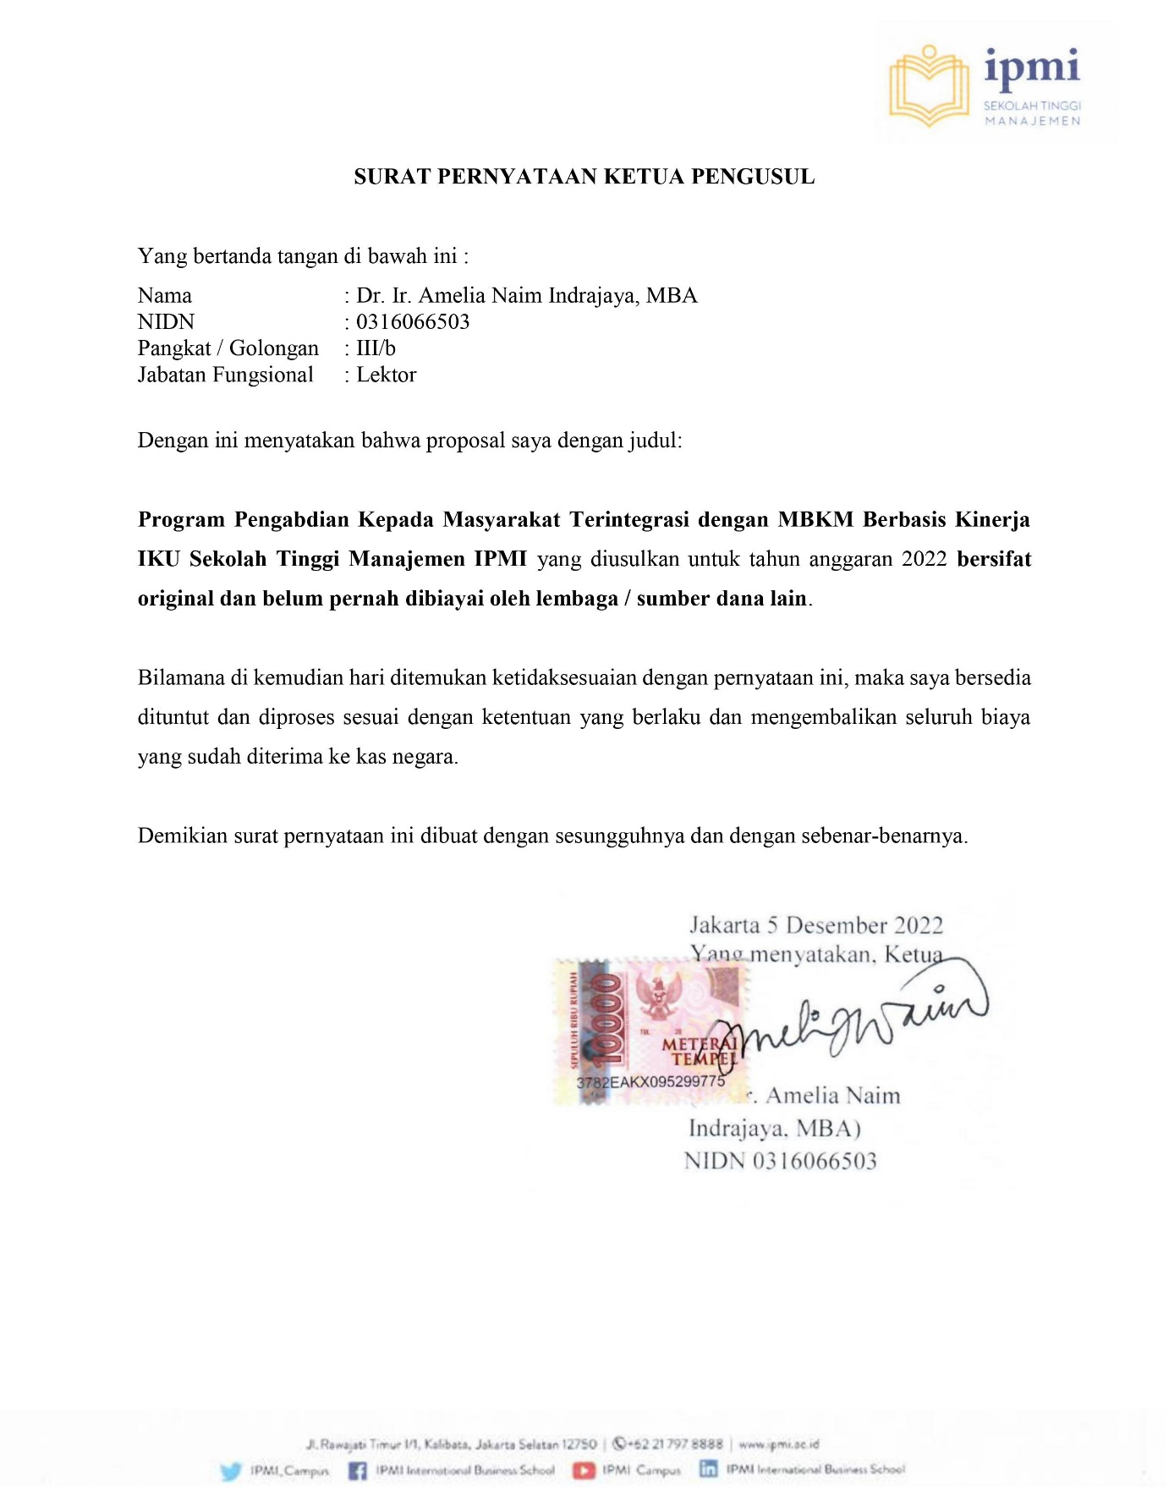
Lampiran 3. Peta dan Gambaran Lokasi
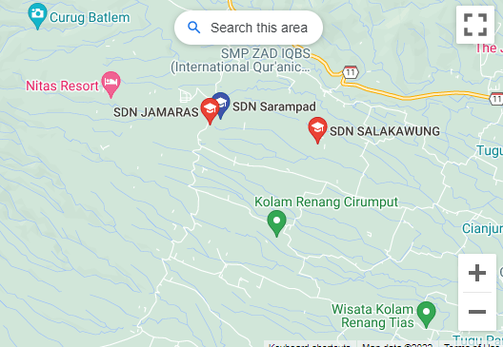
Gambar 8. Lokasi program eksistensi, relasi, dan pengembangan
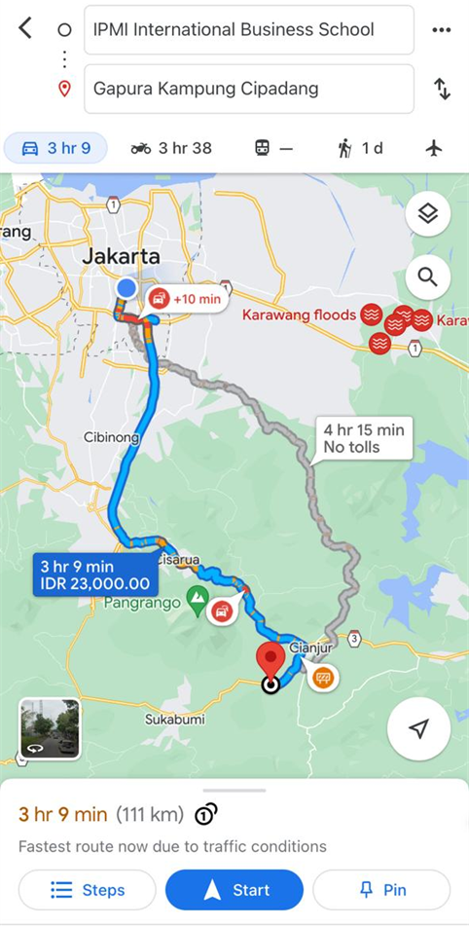
Gambar 9. Lokasi program bangunan tahan gempa dan apotek hidup
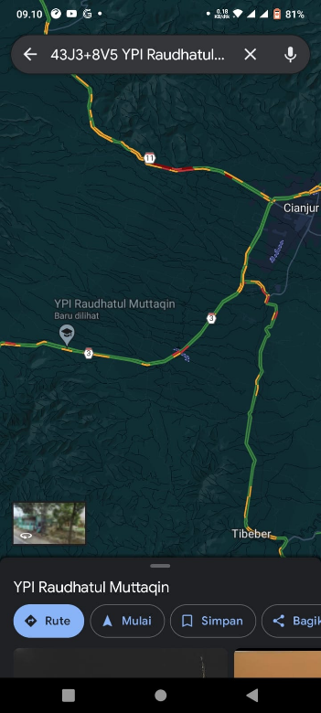
Gambar 10. Kebonpeuteuy, Kec. Gekbrong, Kabupaten Cianjur, Jawa Barat 43261

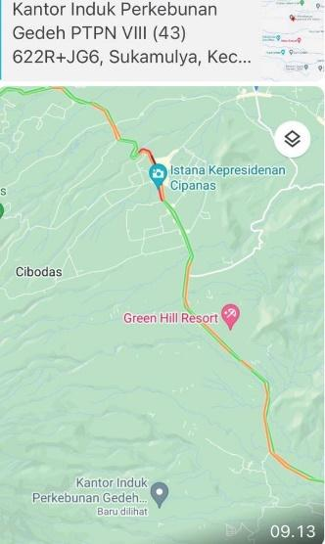

Gambar 11. Kantor Induk Perkebunan Gedeh PTPN VIII

Lampiran 4. Format Surat Pernyataan Kesediaan Kerjasama Mitra
